**Mission:**

The Surface Warfare Medical Institute provides global medical support to the Fleet and Fleet Marine Forces through consultation, operational readiness training, reference publications, research direction and exercise planning. Performs other functions and tasks as directed by higher authority.

**Vision:**

To be recognized as the Center for Excellence in providing well trained and highly effective medical assets for Fleet and Fleet Marine forces deploying in support of national security, sea power and joint exercises.

Additional SWMI Phone Numbers:

Administrative Division: (619) 532-6195

Education/Flt Support: (619) 532-5857

SEL/LCPO: (619) 532-6798

About SWMI

The Surface Warfare Medical Institute (SWMI) is a detachment of Navy Medicine Operational Training Center (NMOTC). It was established April 3, 1998 in San Diego, CA at the Naval Submarine Base, Point Loma. SWMI moved to NSHS San Diego, May 2008.

Between 1993 and 1995, the COMNAVSURPAC and COMNAVSURFLANT Force Medical Officers recognized the need to standardize and upgrade the training of the General Medical Officer assigned to the Fleet.

The staffs at SWMI are a diverse collection of highly qualified professionals and subject matter experts; their qualifications and experiences reflect a broad range of training resulting in various curriculum programs. Accredited by Navy Medicine, Manpower, Personnel Training and Education (NM MPT&E) Command, SWMI provides six major operational courses for CME & CE credits.

**Surface Warfare Medical Institute**

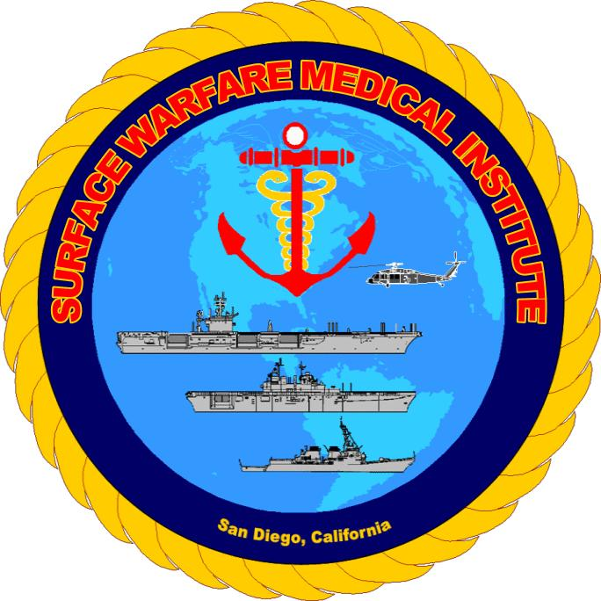

**34101 Farenholt Ave**

**San Diego, CA 92134**

**619-532-6195**

**DSN: 532-6195**

**Fax: 619-532-8251**

**Email:** [**SWMI-ADMIN@med.navy.mil**](mailto:SWMI-ADMIN@med.navy.mil)

**Courses Offered:**

SWMOIC

The Surface Warfare Medical Officer Indoctrination Course (SWMOIC) is a three (3) week introductory course for Medical Corps Officers assigned to the surface fleet as Senior Medical Officers (SMO).  The curriculum introduces them to their administrative duties as a department head, preventive and occupational medicine programs, and health promotions issues, humanitarian operations and medical evacuation.  Clinical topics of special interest varies but may include heat and cold injuries, burn management, orthopedic trauma, triage, chemical and biological warfare.  The course also includes shipboard firefighting basic damage control and Helo Egress training when space is available. The first two weeks are the same as the Surface Warfare Medical Department Officer Indoctrination course.

Offered on East and West Coast annually: July

SWMDOIC

The Surface Warfare Medical Department Officer Indoctrination Course ( ****SWMDOIC**** ) is designed to provide Nurse Corps, Medical Service Corps and Medical Corps Officers, not assigned as department heads, an orientation to the fleet.  It covers the mission of the Navy, medical assets of surface vessels, an overview of administration including inspections, supply, 3 M, records and correspondence.  There is an introduction to the preventive and occupational health programs of a ship, medical regulating and patient evacuation.  This course meets one of the prerequisite for the Surface Warfare Medical Department Officer qualification.

Offered in San Diego, CA, dates vary. Also offered in Portsmouth in July

**CATF/ESG**

**The Command Amphibious Task Force/ESG Surgeon course provided Navy Medical Department Officers with training in expeditionary warfare, amphibious operations and associated Health Service Support in order to serve more effectively as a senior medical advisor to the Amphibious Task Force/Expeditionary Strike Group Commander. This course is open to Foreign Armed Services.**

**Offered annually in San Diego, CA, April (date may vary)**

**Medical Regulating**

**The Medical Regulating course is a 2 ½ day course that provides students with the knowledge and skills required to function as a Medical Regulating Team (MRT) and Patient Evacuation Team (PET) members. The course provides techniques of medical regulating, patient movement, operations, Health Service Support assets, planning, and communications unique to Navy and Marine Corps, as well as the joint operating arena.**

**Offered OCONUS and CONUS, dates vary.**

**OPERATIONAL MEDICINE SYMPOSIA**

The goal is to get medical education to the deck-plates by providing 4 hours of Continuing Medical Education (CME) in a venue that is close to the waterfront. Topics have included mass casualty incidents at sea , the bombing of the USS COLE, Orthopedic & Maxillofacial trauma, Burns, Bioterrorism, Urban Warfare, Avian Bird Flu & Humanitarian Mission review. Topics for future symposiums are clinical topics of interest to operational medical providers determined by the operational requirement.

Offered in San Diego, CA, dates and locations vary.